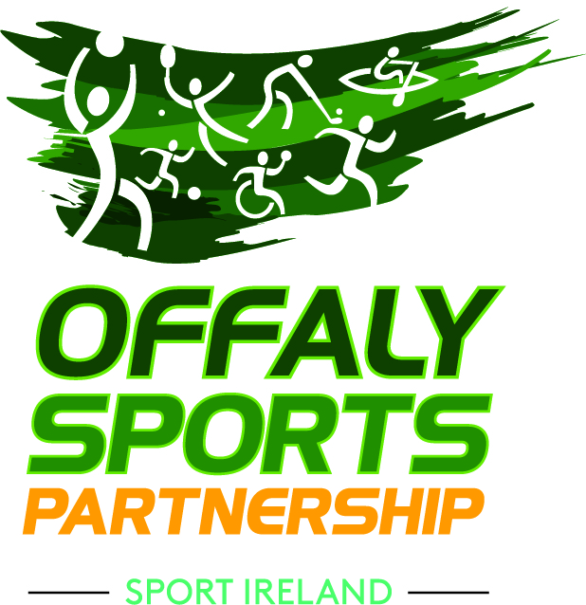
Community & Culture, Offaly County Council, Áras an Chontae,
Charleville Road, Tullamore, Offaly, R35 F893,
T: 057 93 46843/ F: 057 93 46868
E: sports@offalycoco.ie
W: www.offalysports.ie
Strategic Plan 2021 – 2025
Public consultation
At Offaly Sports Partnership we are involved in developing our fourth Strategic Plan which will guide our work over the period 2021 to 2025. As part of a national network of Local Sports Partnerships we are tasked by Sport Ireland to: -

- increase participation levels in sport and physical activity (especially among those sectors of society that are currently under-represented)
- remove barriers and ensure that opportunities for participation in sport are progressive, innovative and fully inclusive at a local level
- support a sustainable level of development within the local sport infrastructure, through support to clubs, groups, coaches and volunteers

We now invite interested parties to make a submission to our strategic planning process

Contact Details (completion of this section is optional)
Contact name
Email address
Telephone number

Would you be willing to take a telephone call if we need to discuss any points raised in your submission?
Yes |  |  | No

If you are submitting this on behalf of an organisation, please provide
Name of organisation
Address of organisation

In our new Strategic Plan, we will outline our actions under five key themes below. We invite you to suggest actions under any of the five themes: -

- Instil fundamentals & Improve youth fitness

- Increase participation in sport and physical activity by adults & older adults

- Include the least active in some form of sport or physical activity

- Integrate & Celebrate sport in our county

- Improve capacity within the local sport sector & Provide relevant up to date information

Submissions to be returned by close of business on Monday, 30th November 2020

